Order Of Service

Singing: Psalm 2—CW page 65

Reading: Psalm 104:14-23

Opening Hymn: TLH 21

Reading: Acts 21:1-16

Request Hymn: CW Supplement 754

Reading: Matthew 8:28-34

Sermon Hymn: TLH 236

Sermon Text: Mark 8:22-26

Men As Trees Walking

Prayer

The Apostles’ Creed, TLH page 12

Holy Communion

The Lord's Prayer

The Blessing

Closing Hymn: TLH 20

* * * * * * * * * * *

Bible Study: Lambs: Great Horned Owl
Sheep: Proverbs 19:6-10
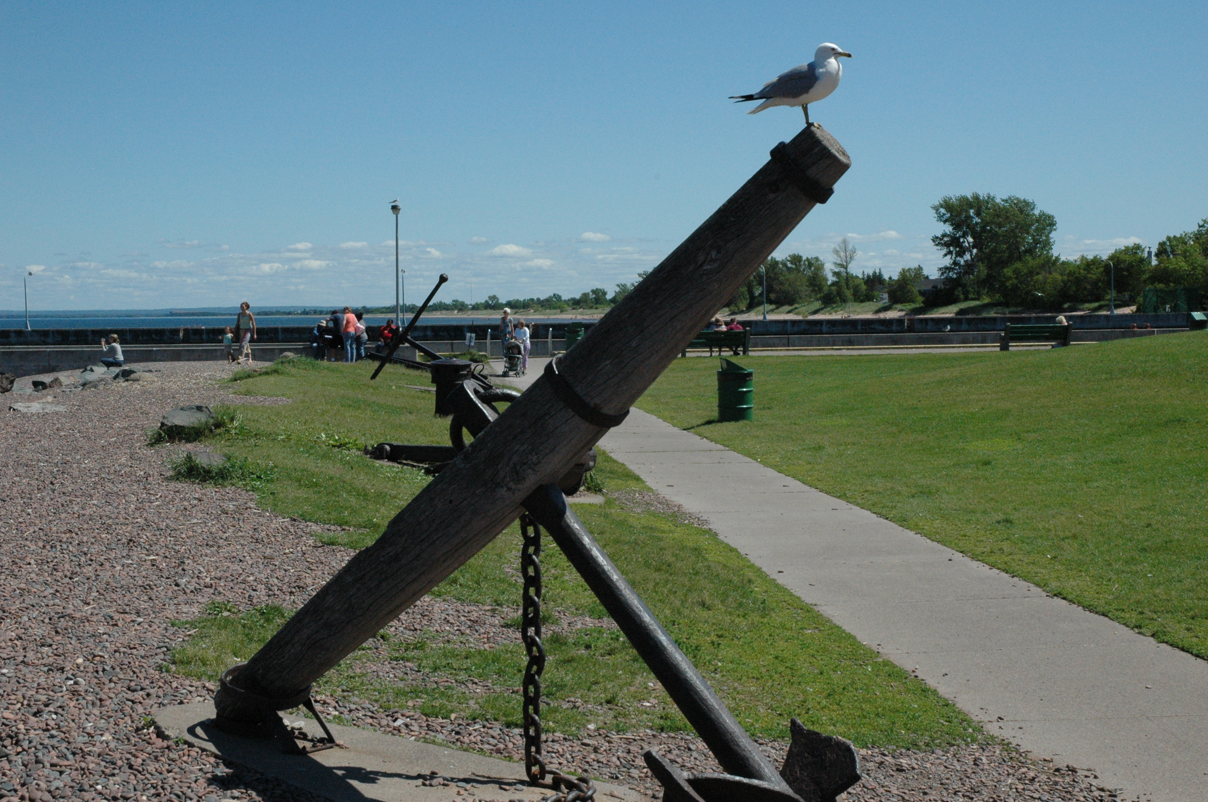

Canal Park—Duluth, Minnesota

Water
Of
Life

21 July 2019

W A T E R O F L I F E

Independent Christian Church—Conservative Lutheran Doctrine

Worship Service: 9:30 a.m. Bible Study: 10:45 a.m.

Larry Cooper, Pastor E-Mail address:
111 N. Ridge Road lcooper@wateroflife.cc
Coon Valley, WI 54623 Web Site:
www.wateroflife.cc

* * * * * * * * * * * * * * * * * * * * * * * * * * *

Sermon Text: Mark 8:22-26

Men As Trees Walking

* * * * * * * * * * * * * * * * * * * * * * * * * * *

Mark 8:22 And he cometh to Bethsaida; and they bring a blind man unto him, and besought him to touch him.
:23 And he took the blind man by the hand, and led him out of the town; and when he had spit on his eyes, and put his hands upon him, he asked him if he saw ought.
:24 And he looked up, and said, I see men as trees, walking.
:25 After that he put his hands again upon his eyes, and made him look up: and he was restored, and saw every man clearly.
:26 And he sent him away to his house, saying, Neither go into the town, nor tell it to any in the town.

Related Readings:

Psalm 1

Psalm 1:1 Blessed is the man that walketh not in the counsel of the ungodly, nor standeth in the way of sinners, nor sitteth in the seat of the scornful.
:2 But his delight is in the law of the LORD; and in his law doth he meditate day and night.
:3 And he shall be like a tree planted by the rivers of water, that bringeth forth his fruit in his season; his leaf also shall not wither; and whatsoever he doeth shall prosper.
:4 The ungodly are not so: but are like the chaff which the wind driveth away.
:5 Therefore the ungodly shall not stand in the judgment, nor sinners in the congregation of the righteous.
:6 For the LORD knoweth the way of the righteous: but the way of the ungodly shall perish.

Jeremiah 17:5-8

Jeremiah 17:5 Thus saith the LORD; Cursed be the man that trusteth in man, and maketh flesh his arm, and whose heart departeth from the LORD.
Jer 17:6 For he shall be like the heath in the desert, and shall not see when good cometh; but shall inhabit the parched places in the wilderness, in a salt land and not inhabited.
Jer 17:7 Blessed is the man that trusteth in the LORD, and whose hope the LORD is.
Jer 17:8 For he shall be as a tree planted by the waters, and that spreadeth out her roots by the river, and shall not see when heat cometh, but her leaf shall be green; and shall not be careful in the year of drought, neither shall cease from yielding fruit.

